Draft of Itinerary

Example: Start Date: June 18, 2018

Passports/Visas = $260 each X 15 = $3,900
Bag Fees = $500 (check 1 bag each on way home only)
Travel Food Allowance $300

June 18, 2018 – Cuban Group Flies from Cuba to SFO

Departure from Havana – AA -802 via Charlotte, NC - 12:15pm - 2:50pm
AA -2029 to SFO - 4:35pm - 7:04pm
Go through US Customs

15 passenger van to pick up guests – or 2, 10 passenger vans (depending on how many are able to come)
Enterprise Rent-a-Car -15 passenger van is $599.99 + tax, totaling $661.42 plus gas...so figure $1,000.00 for the 10 days.

Meet to welcome the Cuban Team in Marin…Assignments to families.
2 players to each family, Coaches included. Need a minimum of 7 families to volunteer for the entire 10 days. If we have enough volunteers/we may share the time 5 days/5 days. Each family will be responsible for all transportation to practices, meals, and shuttle to special events. Donated volunteer costs will be about $1,000 for each player for meals/gas/extras.

June 19, 2018

Breakfast with host families
9am - 9:45am EN-SP Language & Culture Exchange Session

10am – Van to drop off at excursion Big Red Bus Tour of San Francisco $46.80/each person ($750) (Spending money allocated for planned stops $1,500) – Total: $2,250
https://www.bigbustours.com/en/san-francisco/san-francisco-tour-tickets-and-passes/san-francisco-bus-tours/
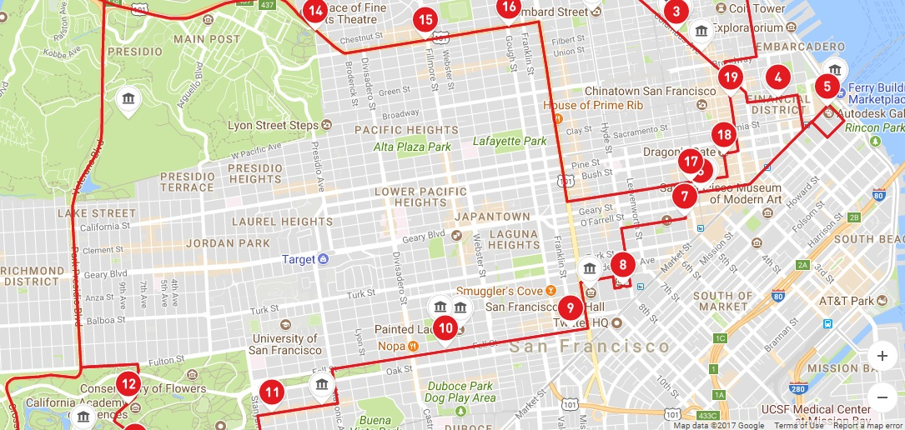

7:00pm Welcome Party (??? House)
Sleep at host families

June 20, 2018

9am - 9:45am EN-SP Language & Culture Exchange Session (At Redwood)

Practice 10am – Meet at Redwood Baseball Field for 2 hour practice.

12pm – From Tiburon - Alcatraz Day Tour $45 – approximately 2.5 hours ($675) – Pack Lunch

Vans to pick up around 4pm in Tiburon and head to SF for Giants game. (If a behind the scene tour can be scheduled at AT&T Park, the schedule will be altered). www.sfgiants.com

Evening Giants Game $25/per person; $50 parking; souvenirs ($1,000)
MONDAY  JUN 18, 2018 | Miami Marlins at San Francisco Giants  AT&T Park - San Francisco, CA | Tickets
TUESDAY  JUN 19, 2018 | Miami Marlins at San Francisco Giants  AT&T Park - San Francisco, CA | Tickets
WEDNESDAY  JUN 20, 2018 | Miami Marlins at San Francisco Giants  AT&T Park - San Francisco, CA | Tickets
Home late.

June 21, 2018

Breakfast with host families
9am - 9:45am EN-SP Language & Culture Exchange Session

10 am - Baseball Practice or Game – Moody Field/Albert Field/Meet with Pacifics Baseball Players (Cost?)

1pm – Vans to Tennessee Valley Trailhead to the ocean. Have van pick up at Point Bonita Light House, Point Reyes. Day at Muir Woods – Hiking with the Redwoods https://www.nps.gov/muwo/index.htm ($10/per person) ($150) Have bagged lunches packed.

Option 1 - Dinner with Host Family
Option 2 – Pizza Donated from Round Table at the Headlands

7:00pm - Drive up to Marin Headlands, hike out to Battery Spencer, and watch the sunset (8:36pm) over San Francisco and the Golden Gate Bridge come alive at night. https://www.google.com/maps/place/Battery+Spencer/@37.8277584,-122.4950132,16z/data=!4m5!3m4!1s0x80858682bf7bd5e3:0x895d436665f57085!8m2!3d37.8277124!4d-122.4816625

Sleep at host family’s home.

June 22, 2018

Breakfast with host families
9am - 9:45am EN-SP Language & Culture Exchange Session

10am - Baseball practice or game – Moody Field

12pm – Van pick up - Meet in Tiburon for Angel Island Tour
Tram Tour is $16.50/per person. Hike to top of the hill for great views/packed lunches. ($300)
https://angelisland.com/

Parents to pick up at 4pm. Free afternoon.

Dinner with Host Families.

June 23, 2018

Breakfast with host families.

Eagle Scout Project Day – All Day! Repair, maintain, improve a local field.
All meals included, bring your muscles!

June 24, 2018

Breakfast with host families
9am - 9:45am EN-SP Language & Culture Exchange Session

10am - Baseball Game at Moody Field (US vs. CUBA) Game #1

12:30pm – Lunch at Shopping Mall Food Court

Afternoon - House of Air $14/hr ($250)

Free Host Family Afternoon. Pack for Camping. Sleeping bags and tents provided.

Sleep at host family’s home.

June 25, 2018

Sleep-in day.

Local camping trip overnight. Meet in Tiburon, leave at 11am. Fishing, dinner, campfire, ??? ($50 facility, $100 food)
Point Reyes Station, Check for Bon Fire places; Bolinas? (Research)???

June 26, 2018

Camping trip continues - Breakfast, outdoor activites, lunch.
Return home at 2pm.

Driven Raceway in Rohnert Park ($500) – If donated only. (May be substituted).

Cultural Night Out in Town (theater/music)

Sleep at home family’s home.

June 27, 2018

Breakfast with host families
9am - 9:45am EN-SP Language & Culture Exchange Session

Practice or game 10am at Moody field.

Group Swim Party at Volunteer’s House.

Final evening with host family.

June 28, 2018 Cuban Group Flies from SFO to Cuba

Breakfast with Host Families

Pick up 9am with Van – arrive 2 hours before flight.

Depatrure - TBD

Summary of costs:
Passposts/VISAs $3,900
Travel Bag Fees $500
Travel Food Allowance $300
Airfare: $7,000
Van/Gas $1,000 – Donate (Van)?
Red Bus Tour Day $2,250
Alcatraz $675
Giants Game $1,000 – Donate?
Pacifics Game/Practice $300 – Donate?
Tennessee Valley/Muir Woods $200 – Donate?
Angel Island $300 – Donate?
Eagle Scout Project Day $3,000 (Update)
House of Air $250 – Donate?
Camping $300
Driven Raceway $500 – Donate?
Goodbye Party $300
Professional Help - $2000
TBD: Jake to Meet Cuban Parents and Players in Cuba for Orientation - $1,500 (Maybe)
$25,275 (if nothing donated)
$21,725 (if all donated)

Have any connections or want to sponsor any of the events above? Please contact me!

